Finance KPIs (App 213) — UAT Results
Round 1 · 28-Jul-2026 · Automated runner: assessment-3/phase4/tests/uat_run_kpi.py
Summary: 18 / 18 cases PASS
Case | Area | Test Case | Status | Actual / Notes
KPI-01 | Dashboard | Scorecard dashboard renders | PASS | 4 cards
KPI-02 | Registry | Registry lists the 4 circular KPIs | PASS | 4 rows
KPI-03 | Registry | OPT_PLAN carries full circular content | PASS | bands=5 criteria=4
KPI-04 | Security | Non-admin blocked from configuration | PASS | (403, 403)
KPI-05 | Periods | Measurement calendar generation | PASS | 5 periods
KPI-06 | Results | Quarterly KPI rejected on an annual period | PASS | 400
KPI-07 | Results | Ratio KPI computes and scores live | PASS | {'resultPct': 108, 'score': 5, 'ok': True}
KPI-08 | Results | Maturity rubric weighted scoring | PASS | {'resultPct': 80, 'score': 5, 'ok': True}
KPI-09 | Validation | Submission blocked without required evidence | PASS | (400, {'error': 'ORA-20001: At least one evidence document is required before submission'})
KPI-10 | Evidence | Upload above MAX_UPLOAD_MB rejected | PASS | 413
KPI-11 | Evidence | Evidence upload, register and download | PASS | (200, 200, 200)
KPI-12 | Workflow | Submission starts the approval chain | PASS | {'status': 'SUBMITTED', 'wfInstanceId': 25, 'resultPct': 80, 'score': 5}
KPI-13 | Workflow | Figures locked while under approval | PASS | 400
KPI-14 | Workflow | Task in the shared worklist with server outcomes | PASS | ['APPROVE', 'REJECT', 'RETURN']
KPI-15 | Workflow | Two-step chain approves and completes the result | PASS | ('APPROVED', 3)
KPI-16 | Dashboard | Scorecard reflects the approved measurement | PASS | (5, 5)
KPI-17 | Reports | KPI Briefing Book generated and downloadable | PASS | ('SUCCESS', 200)
KPI-18 | i18n | Arabic interface with RTL layout | PASS | ltr

Evidence
KPI-01 — Scorecard dashboard renders (PASS)
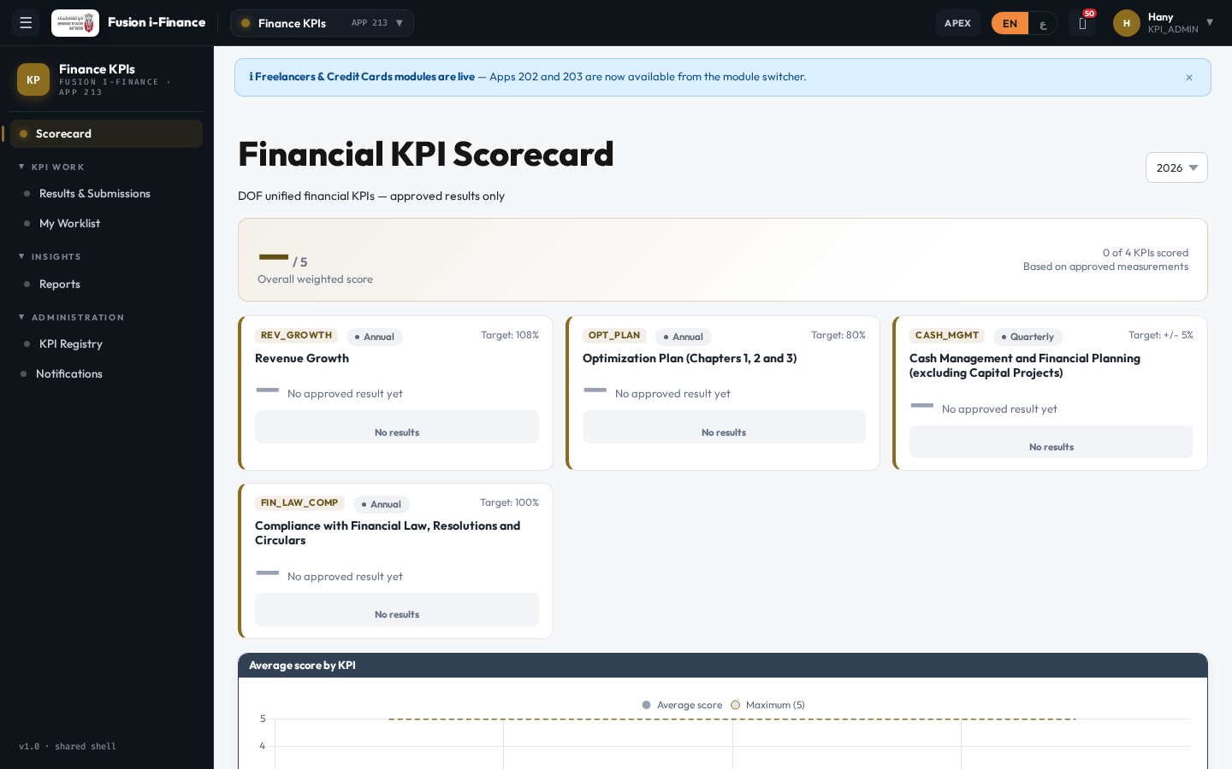
KPI-02 — Registry lists the 4 circular KPIs (PASS)
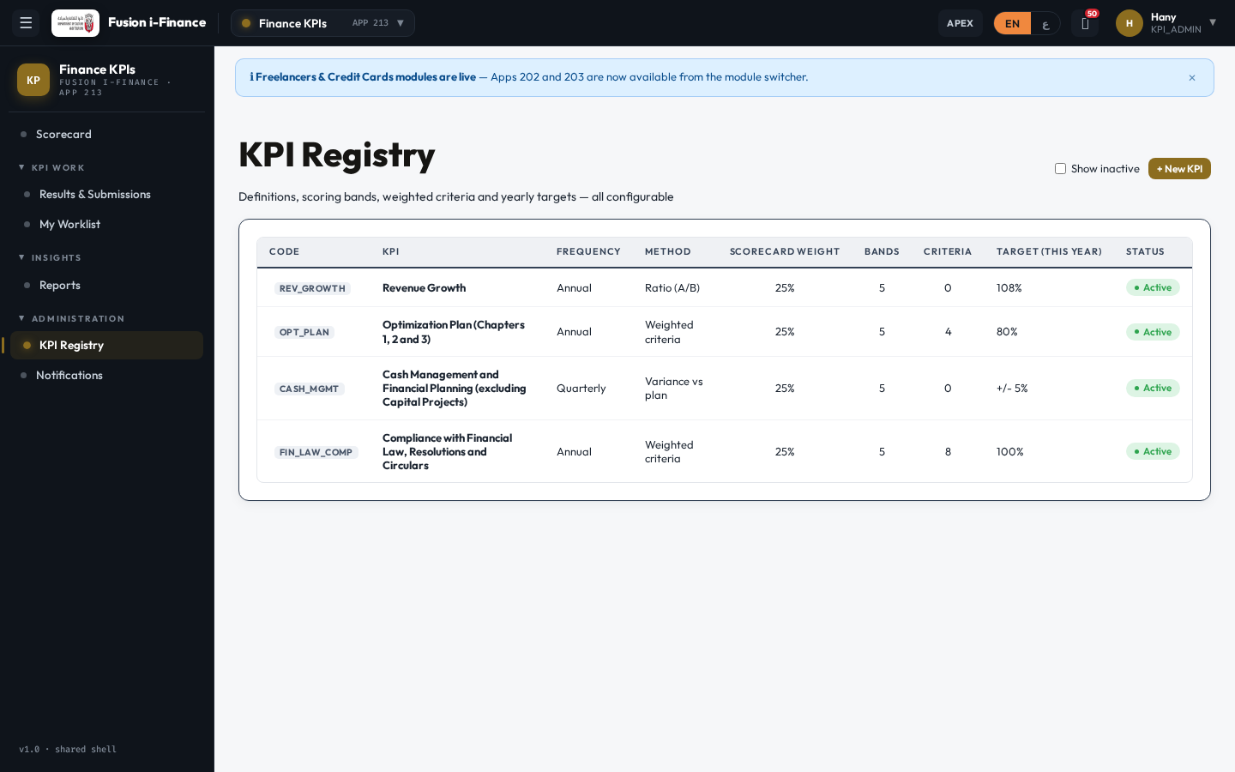
KPI-03 — OPT_PLAN carries full circular content (PASS)
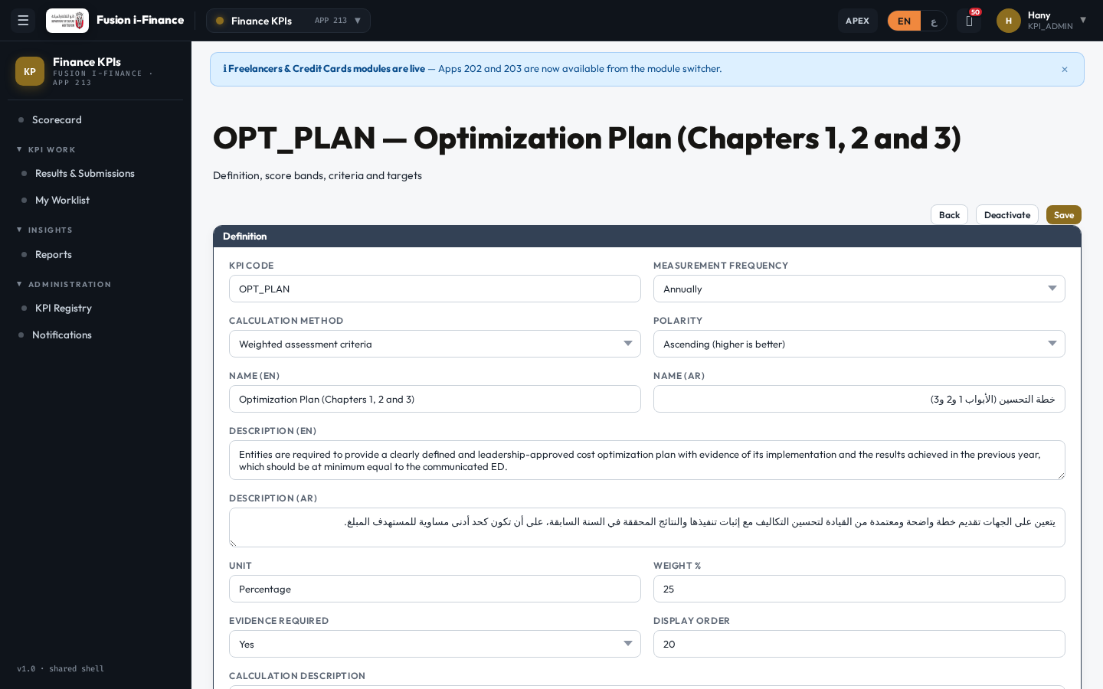
KPI-04 — Non-admin blocked from configuration (PASS)

KPI-05 — Measurement calendar generation (PASS)

KPI-06 — Quarterly KPI rejected on an annual period (PASS)

KPI-07 — Ratio KPI computes and scores live (PASS)
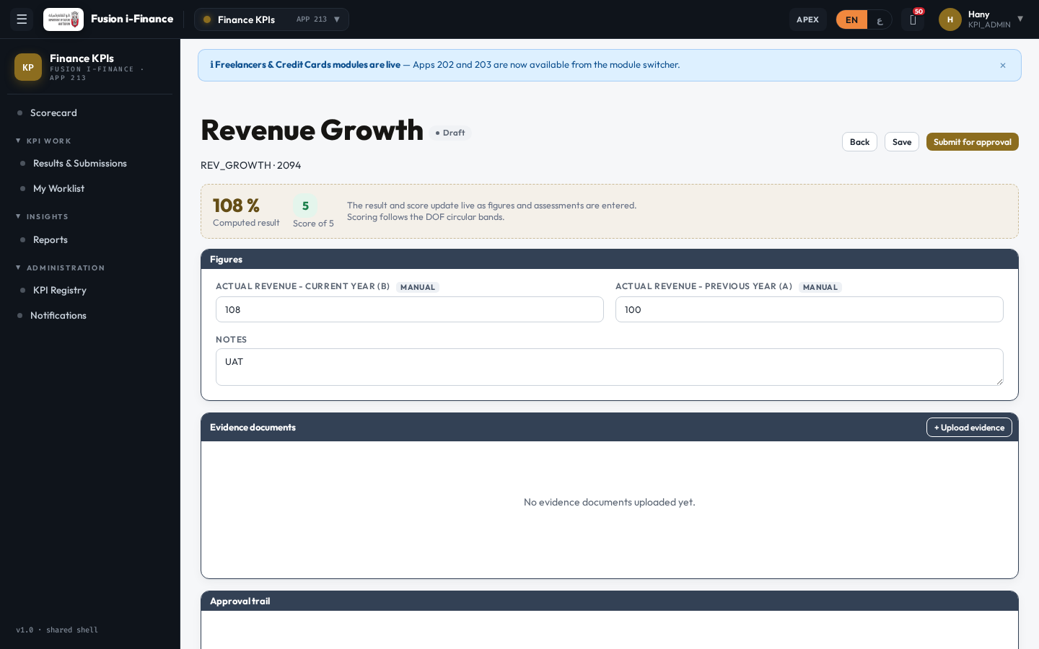
KPI-08 — Maturity rubric weighted scoring (PASS)
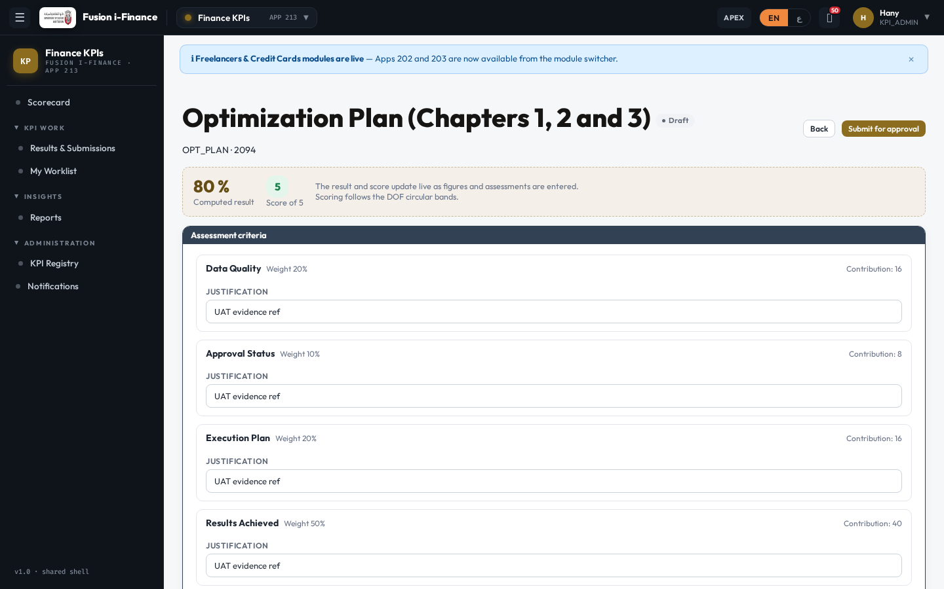
KPI-09 — Submission blocked without required evidence (PASS)

KPI-10 — Upload above MAX_UPLOAD_MB rejected (PASS)

KPI-11 — Evidence upload, register and download (PASS)

KPI-12 — Submission starts the approval chain (PASS)

KPI-13 — Figures locked while under approval (PASS)

KPI-14 — Task in the shared worklist with server outcomes (PASS)
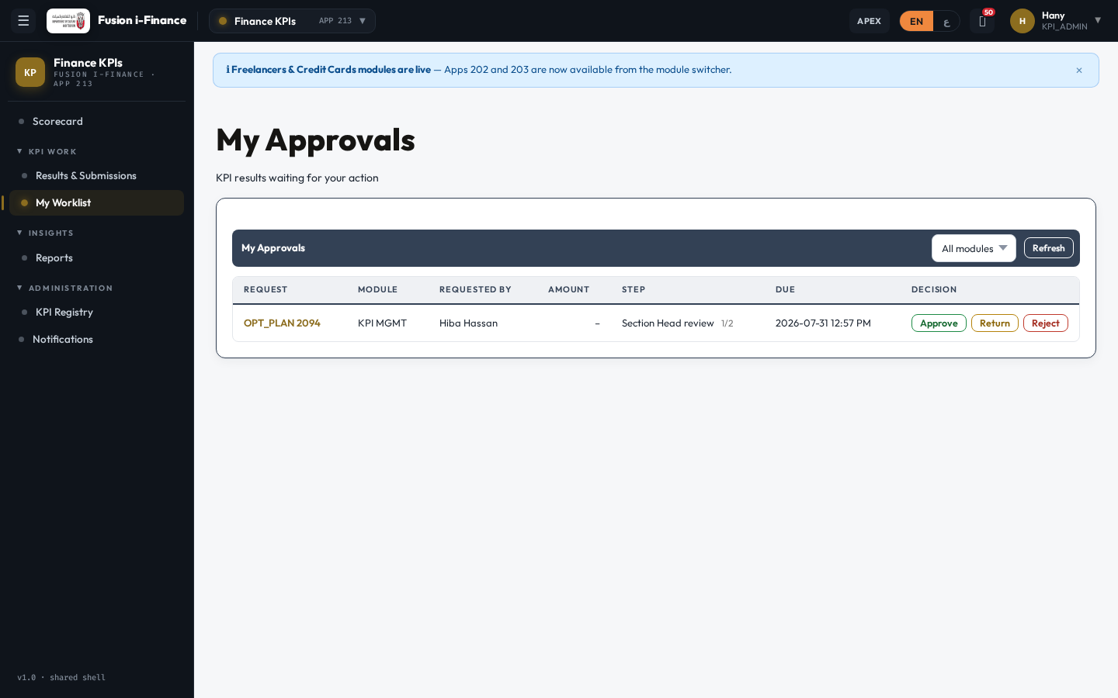
KPI-15 — Two-step chain approves and completes the result (PASS)
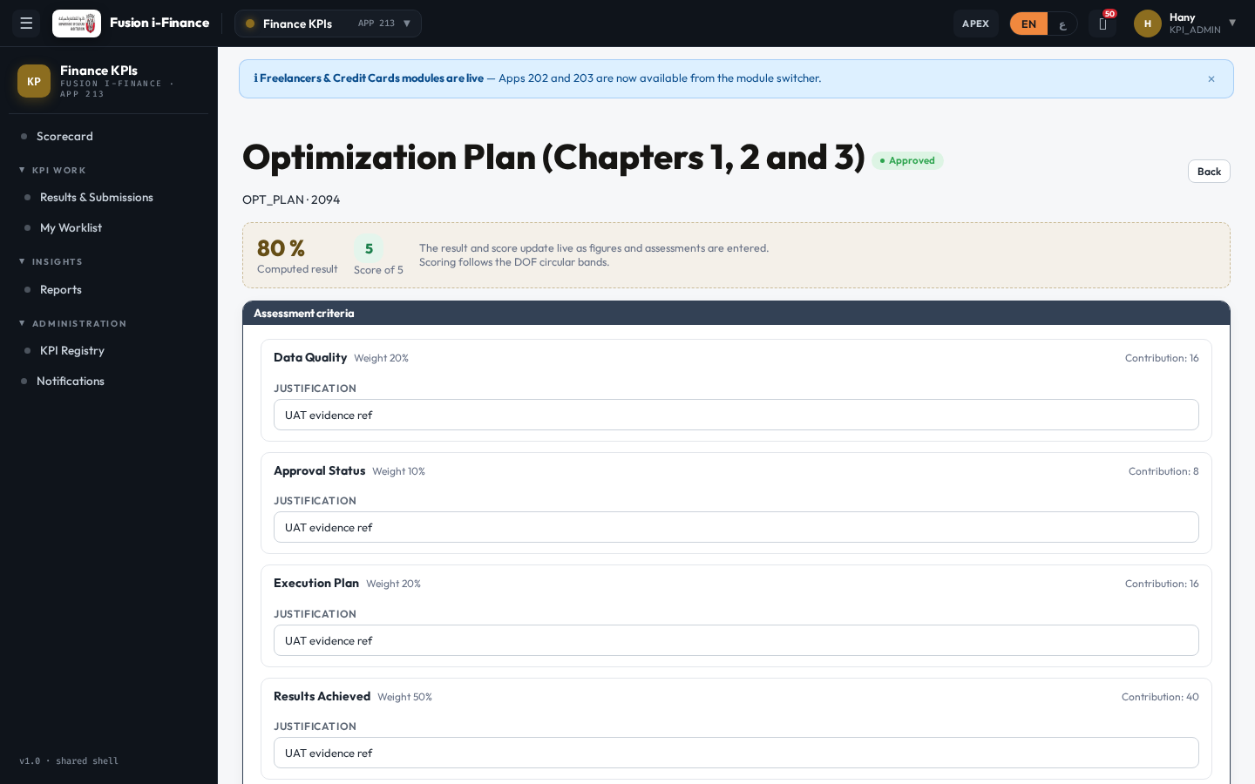
KPI-16 — Scorecard reflects the approved measurement (PASS)
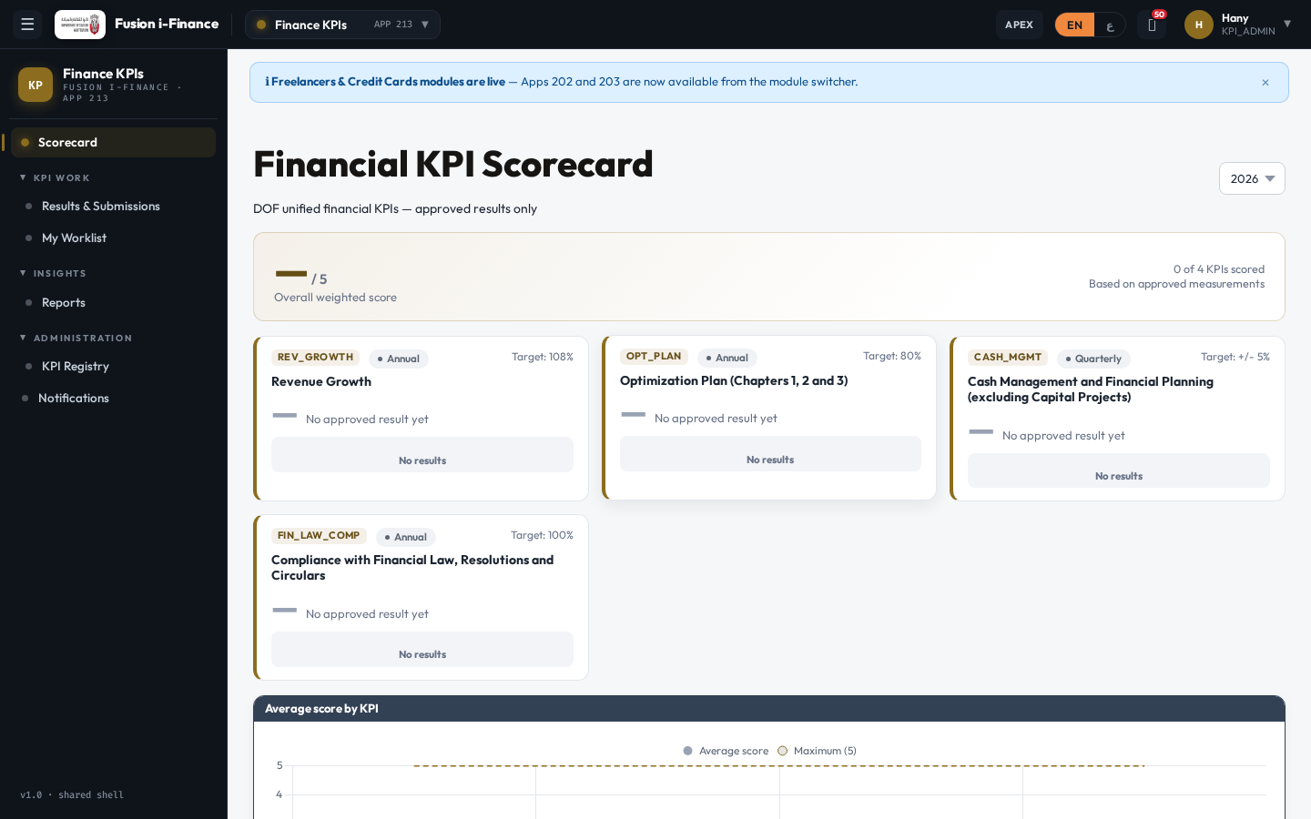
KPI-17 — KPI Briefing Book generated and downloadable (PASS)
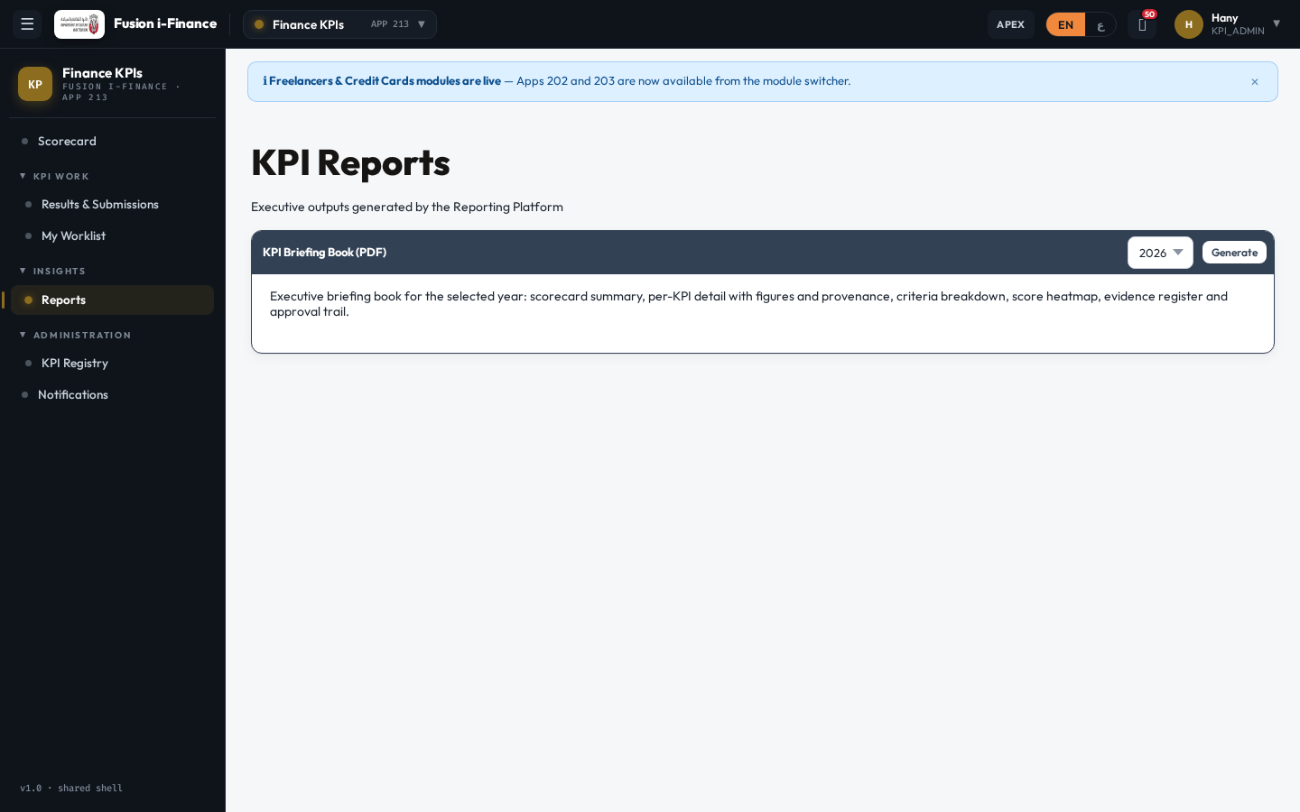
KPI-18 — Arabic interface with RTL layout (PASS)
